Skin Cancer

Peggy M. grew up in the sunshine, and always had a nice tan. Now, at 66, she is bothered by several rough, bumpy areas on the backs of her hands. One of them seems to be growing and bled when she bumped it.
What Is Skin Cancer?   | Our skin protects us against the environment and all the things in it that might do us harm. It renews itself throughout our lives. But injury, particularly injury from the sun, can upset this repair process and can produce skin cancer.  Skin cancer is the most common type of cancer. Nearly half of all those who live to age 65 will develop at least one skin cancer.  Skin cancer is nearly always curable if found early. You should take an interest in your skin and how you can help prevent and detect skin cancer.
What Types of Skin Cancer Are There? | Skin cancer can be non-melanoma or melanoma. The term “melanoma” refers to a cancer of the cells that give skin its color.  There are two non-melanoma cancers, basal cell and squamous cell. These cancers:  • Occur on areas of the skin exposed to the sun  • Are cured with fairly minor surgery  • Usually do not spread unless they are ignored  Melanoma resembles moles and can be found on any skin area. This cancer:  • Is more dangerous than other skin cancers because it invades and destroys nearby tissue  • Is easily cured if found in the early stages

What Do I Look For? | You should check your skin once a month. Use a hand mirror for areas that are hard to see.  If you have any worries about changes in your skin, see your doctor or a dermatologist.
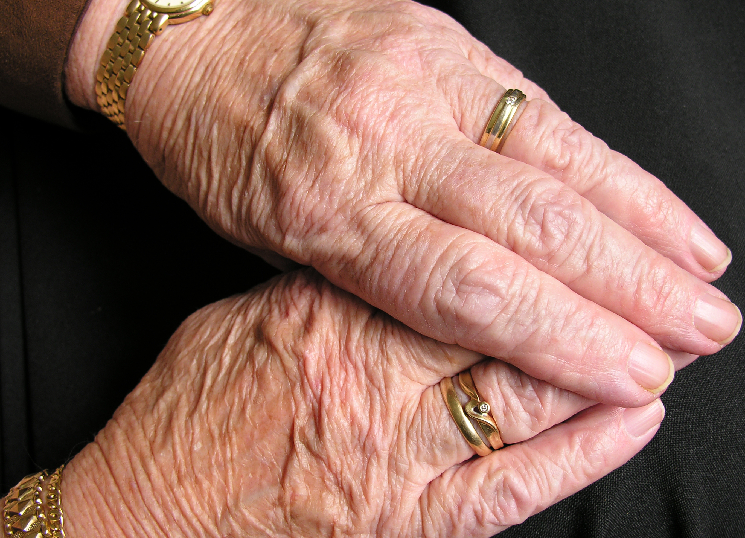 | Squamous Cell Cancer  Look for the following:  • A wart-like growth that crusts and occasionally bleeds  • A long-lasting, scaly red patch with irregular borders that sometimes crusts or bleeds  • An open sore that bleeds and crusts, and does not heal  • An elevated growth with a central depression that occasionally bleeds  • A growth of this type that rapidly increases in size
Basal Cell Cancer
Look for the following:
• An open sore that bleeds or remains open for 3 or more weeks
• A reddish patch or irritated area that hurts or itches
• A shiny bump that is pearly or clear, and is often pink, red, or white
• A pink growth with a slightly raised edge and crusted dimple
• A scar-like area that is white, yellow, or waxy

What Do I Look For?  continued | Melanomas  Melanomas can be suspected by using the ABCD test on moles you may find on your body:  • A is for Asymmetry (one half not the same as the other)  • B is for an irregular Border  • C is for more than one Color in the same mole  • D is for Diameter (width) — larger than a pencil eraser  See your doctor quickly if a mole is getting bigger.
How Can I Protect Myself? |  | Skin cancer is caused by sun exposure. Staying out of the sun, particularly from 10:00 am to 2:00 pm when sun damage is the worst, is the most important thing you can do to prevent skin cancer.
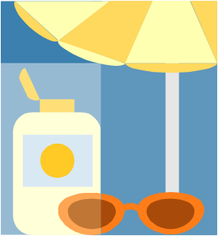 |  | Sun-Protective Clothes  Protective clothing, such as long sleeves, hats, sunglasses, and sunscreen also help prevent skin cancer.  You can now buy special sun-protective clothing.  Sun-protective clothes look like regular clothing, so you have to check them closely to see if they will protect you from the sun. Generally, sun-protective clothes:  • Have a tighter weave or knit than traditional fabrics  • Are usually a dark color  • Are labeled with the level of protection the clothing provides from the sun's UV (ultraviolet) rays
Sunscreen
Using sunscreen can also help prevent skin cancer. Be sure to use sunscreen on sunny and cloudy days, but don't stay out in the sun longer just because you have it on.

Resources | Organizations  National Cancer Institute —  The Cancer Information Service (CIS)  Phone: (800) 4-CANCER (422-6237)  TTY: (800) 332-8615  Web site: www.cancer.gov  Live web chat line: www.cancer.gov/help  This program provides accurate, up-to-date information about cancer. Specialists answer questions in English or Spanish, on TTY equipment or on the live web chat line.  The Skin Cancer Foundation  245 5th Avenue Suite #1403  New York, NY 10016  Phone: (800) SKIN-490 (754-6490)  Fax: (212) 725-5751  E-Mail: info@skincancer.org  Web site: www.skincancer.org  The Skin Cancer Foundation provides basic information for health care professionals and the public on the prevention, detection, and treatment of skin cancer.

